Jason Kwok
Given Code
$sel1 = mysql_query(
"SELECT ID, name, locale, lastlogin, gender
FROM USERS_TABLE
WHERE (name = ’$user’ OR email = ’$user’) AND pass = ’$pass’");
$chk = mysql_fetch_array($sel1);
if (found a record)
{
allow user login;
}

Attempting to login using SQL injection. Since the code to login looks for a username + password combo but we already know the username, we can comment out the password check so the code only looks for a username. This will allow you to login without knowing the password for “ted”. This is done by adding “‘) -- “. – is to comment out the password check.
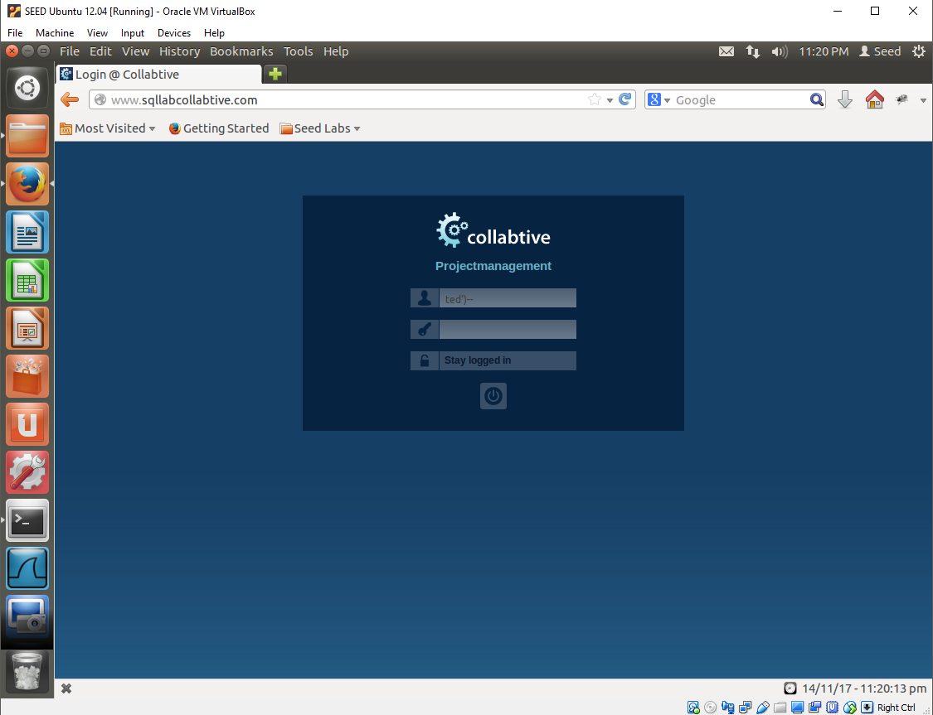
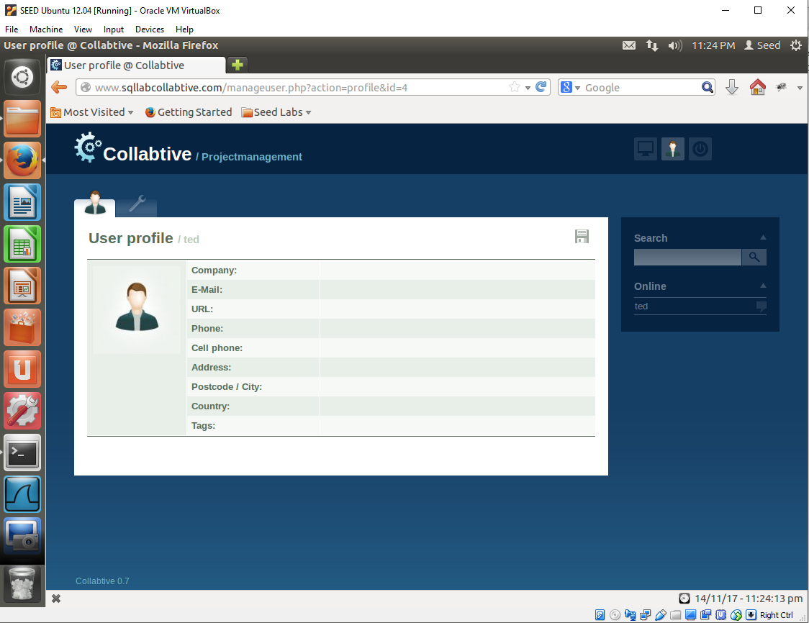
Now attempting to login with a blank username. Similarly, we don’t need the password, we can just comment that out with “‘) -- “ but for the username we can add another condition to it. Since it’s a username or email, we can add another condition such as ‘ OR ‘1’=’1’ which evaluates to true. So the full username would be “‘ OR ‘1’=’1’) -- “. The website assumes that I am the administrator.
